**ITA 0443 - STATISTICS WITH R PROGRAMMING FOR REAL TIME**

**PROBLEM**

**DAY 4– LAB MANUAL Part 2**

**Reg No: 192121154**

**Name: S. DHANUSH KUMAR**

**LOGISTIC REGRESSION ANALYSIS IN R**

**Exercise**

**5. Create a logistic regression model using the “mtcars” data set with the information given**

**below.**

**The in-built data set &quot;mtcars&quot; describes different models of a car with their various engine**

**specifications. In &quot;mtcars&quot; data set, the transmission mode (automatic or manual) is described**

**by the column am which is a binary value (0 or 1). Create a logistic regression model**

**between the columns &quot;am&quot; and 3 other columns - hp, wt and cyl.**

**PROGRAM:**

#load the mtcars data set

data(mtcars)

#fit a logistic regression model

model <- glm(am ~ hp + wt + cyl, data = mtcars, family = binomial)

#display the model summary

summary(model)

**OUTPUT:**

> data(mtcars)

> #lead the mtcars data set

> model<-glm(am~hp+wt+cyl,data=mtcars,family=binomial)

> summary(model)

Call:

glm(formula = am ~ hp + wt + cyl, family = binomial, data = mtcars)

Deviance Residuals:

Min 1Q Median 3Q Max

-2.17272 -0.14907 -0.01464 0.14116 1.27641

Coefficients:

Estimate Std. Error z value Pr(>|z|)

(Intercept) 19.70288 8.11637 2.428 0.0152 *

hp 0.03259 0.01886 1.728 0.0840 .

wt -9.14947 4.15332 -2.203 0.0276 *

cyl 0.48760 1.07162 0.455 0.6491

---

Signif. codes: 0 ‘***’ 0.001 ‘**’ 0.01 ‘*’ 0.05 ‘.’ 0.1 ‘ ’ 1

(Dispersion parameter for binomial family taken to be 1)

Null deviance: 43.2297 on 31 degrees of freedom

Residual deviance: 9.8415 on 28 degrees of freedom

AIC: 17.841

Number of Fisher Scoring iterations: 8

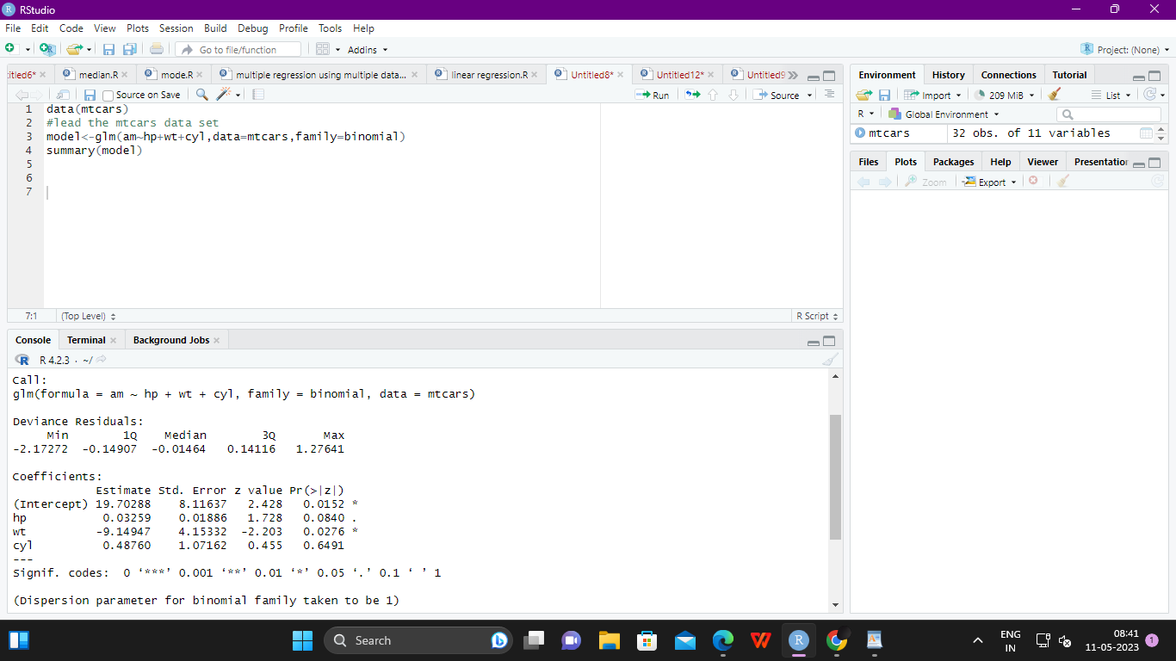

**POISSON REGRESSION ANALYSIS IN R**

**Exercise :**

**6. Create a Poisson regression model using the in-built data set “warpbreaks” with**

**information given below.**

**In-built data set &quot;warpbreaks” describes the effect of wool type (A or B) and tension (low,**

**medium or high) on the number of warp breaks per loom. Consider &quot;breaks&quot; as the response**

**variable which is a count of number of breaks. The wool &quot;type&quot; and &quot;tension&quot; are taken as**

**predictor variables.**

**PROGRAM:**

#load the warpbreaks data set

data(warpbreaks)

#fit a Poisson regression model

model <- glm(breaks ~ wool + tension, data = warpbreaks, family = poisson)

#display the model summary

summary(model

**OUTPUT:**

Call:

glm(formula = breaks ~ wool + tension, family = poisson, data = warpbreaks)

Deviance Residuals:

Min 1Q Median 3Q Max

-3.6871 -1.6503 -0.4269 1.1902 4.2616

Coefficients:

Estimate Std. Error z value Pr(>|z|)

(Intercept) 3.69196 0.04541 81.302 < 2e-16 ***

woolB -0.20599 0.05157 -3.994 6.49e-05 ***

tensionM -0.32132 0.06027 -5.332 9.73e-08 ***

tensionH -0.51849 0.06396 -8.107 5.21e-16 ***

---

Signif. codes: 0 ‘***’ 0.001 ‘**’ 0.01 ‘*’ 0.05 ‘.’ 0.1 ‘ ’ 1

(Dispersion parameter for poisson family taken to be 1)

Null deviance: 297.37 on 53 degrees of freedom

Residual deviance: 210.39 on 50 degrees of freedom

AIC: 493.06

Number of Fisher Scoring iterations: 4

